

# Final International University

# Final International University Technical Report Writing Standard

# Faculty of Engineering

# Department of Computer Engineering

# Mahmoud Aburub

# Student Name: Ahmet Adam

# Student ID: 202020202

# 2021

## Summary

Students struggle while they are writing reports or presentations during their studies in the university or career, they may suffer or feel frustrated while they are writing reports to their instructor or manager. Since they have no road map in advance that represents the standard for the university or the company they work in. This paper is showing the students how to write a successful report for their career and university, they will learn the standard that will help them search for the ambient they work in such as working in inventory or for university. The paper contains the standard technical report structure and the presentation for assessment of the report. They will have a list of contents and a brief description for every technical report section.

## List of Contents

Table of Contents

1. Introduction 4

2. Structure of the report 4

2.1. Contents of reports 4

3. Structure of presentation 5

4. Revising the first draft 6

5. IEEE References format 7

6. Equations 8

7. Plagiarism 9

8. References 9

9. Acknowledgment 9

10. Appendix A: Table of Contents 9

## List of Figures

Figure ‎2.1.1 Writing technical report draft 5

Figure ‎3.1 Title slide layout selection 6

Figure ‎3.2 Example of a title slide 6

Figure ‎4.1 Selecting cross-reference from figure list 7

Figure ‎4.2 Select information slide layout 7

Figure ‎4.3 Information slide layout example 7

Figure ‎6.1: Superscribing tools using Microsoft Word 8

Figure ‎6.2 Convert text to table 8

Figure ‎10.1 Selecting table of contents format 10

Figure ‎10.2 Information pop-up window 10

Figure ‎10.3 Select which text is included in a table of contents 10

Figure ‎10.4 Updating the contents of the table of contents 10

Figure ‎10.5 Table of contents example 11

## Introduction

A technical report is a formal report designed to convey technical information in a clear and easily acceptable format. Students at Final International University will use this manual for their report structure. The student will start writing the contents of the research or practical work in inventory, and then they will start writing the conclusion, followed by the introduction. The result of this stage will be the first draft, where the contents and format could be done later in the revision of the draft.

## Structure of the report

## Contents of reports

A technical report should contain the following sections as stated in TABLE ‎2.1.1, Tables must be labeled for reference, and try to represent the table after the text you were referencing. To label the table you have two methods, firstly select the table, then right-click, and insert the caption. Alternatively, you can select the references menu and insert a caption. The label format, which must be Table, followed by the Number of the table under the header, contains it.

Figures must contain a header under them with a numbering system that includes “section number dot the figure number”, you can add a figure label by inserting a caption. Figure 2.1.1 shows the steps for writing a technical report draft. The font for the figure label and description must be Times New Roman with 10pt, the Figure and table labels must be bold, and the color must be black for better recognition. The table must be 100% width, and figure dimensions must be 2.6” width by 3.4” height, but if the figure contents are not clear you can alter the figure dimension with a max dimension 5.4” width by 8.0” height.

#### **TABLE ‎2.1.1** Contents of technical report

|  |  |
| --- | --- |
| Contents | Description |
| Title Page | What is the title of the training/ project you are working on |
| Summary | The abstract which includes the work and results |
| Contents | The contents of reports with page numbers |
| Introduction | Introduce what your aim from this study or experience |
| Body | Divided into numbered and headed sections, these sections separate the different main ideas in a logical order. |
| Conclusions | Summarize the founding you explained in the body |
| References | Follow IEEE referencing standard |
| Acknowledgment | List of people who helped your research or prepare the report, including your proofreaders. |
| Appendices (if applicable) | You can include extra resources such as source code |

Try not to put all figures and tables in a sequence of pages since it will be harder for the reader to keep moving from current pages to backward pages, you must show the figure after you reference it as soon as possible. Never put a figure before you use it. Keep one line before and after the figures and tables. You can format the figure to be on the next page where you first mention it.

You must keep one line between two paragraphs and between the header and text. Meanwhile, the paragraph must be in Justify format for easier representation of lines for the reader. Sometimes, you can find some text, which makes alignment Left or Right, but the end of the line will be ambiguous and may be uncomfortable for the reader. It is better for the paragraph must not exceed six lines; try to separate every idea or topic in one paragraph. If your table is separated into two pages, try to write the text preceding it before it. Readers do not prefer to traverse two pages for tables, since the columns, and headers are not included, and the reader may mix up if the table contains much information.

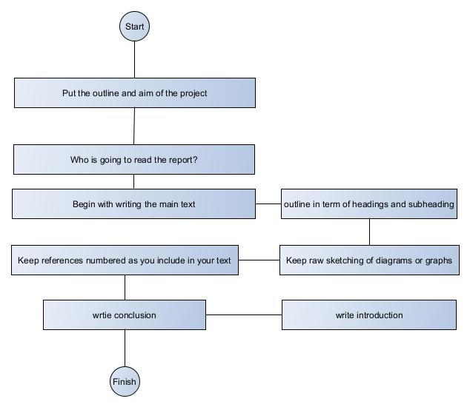

Figure ‎2.1.1 writing technical report draft

## Structure of presentation

Presentation used for assessment of your work; it must be included in your report folder if you sending it online and a hard copy must be forwarded to the instructor within 1 week from the date of submitting the report online or by using the university online infrastructure. The headers of the presentation must be Times New Romans 24pt, and the text must be 18pt, you can check that your font is accurate while representing on the monitor LCD or intelligent TV system. Print the presentation and put it on a book or anything that you handle easily and open your arm to the maximum position. If you can read the paper easily, then it will read easily on the machine. The title page must not contain a slide number, but the other slides must contain a page number. The title page and the information slide must follow the format shown in Figure *‎3*.*1*. Notice that adding a cross-reference is necessary. You can add it by clicking on the reference’s menu (click cross-reference 🡪 chose figures from the pop-up window and select show only label and number) as shown in Figure *‎4*.*1*. The information slide format is different slightly from the title page where information is represented and organized using a number or using special bullets for more declarative representation. Figures Figure *‎4*.*2* and Figure *‎4*.*3* are showing the layout and example for information slides respectively.

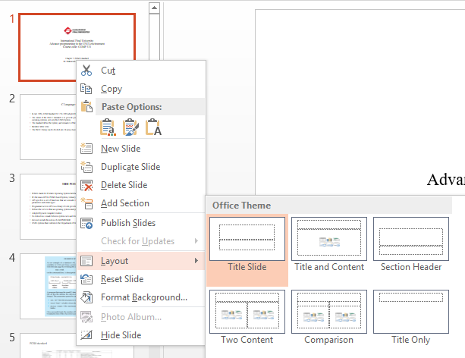

Figure ‎3.1 title slide layout selection



Figure ‎3.2 title slide example

## Revising the first draft

In this stage, your report will start to have shape, while revising your draft you must bear in mind the following:

1. Did your report accurately and concisely convey the intended information?
2. Does that sentence/paragraph/section represent what you mean?
   1. YES, do nothing and continue
   2. No, rewrite them again in a different way
3. Is there any word/ phrase/ sentence/ paragraph that could be removed without affecting the information intended to declare?
4. You may ask a technical writer for help, but you must include his name in your report.

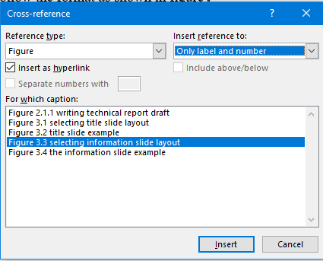

Figure ‎4.1 selecting cross-reference from figure list

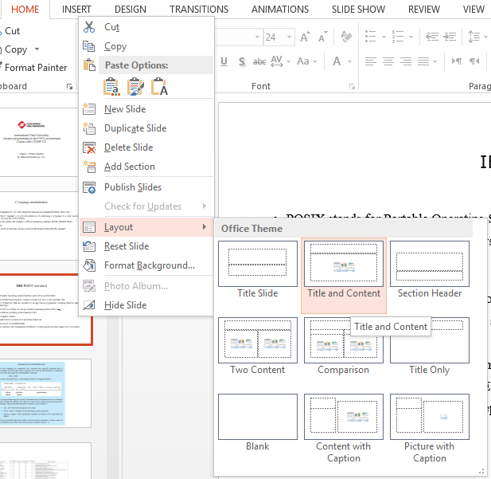

Figure ‎4.2 select information slide layout

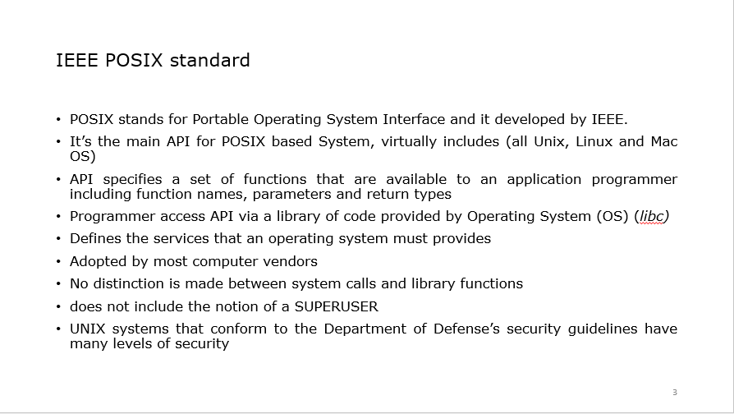

Figure ‎4.3 Information slide layout example

## IEEE References format

IEEE citation style is used primarily for electronics, engineering, telecommunications, computer science, and information technology reports. The font of references must be Times New Romans with 10pt and the text color must be black. The three main parts of IEEE citation references are:

1. The Author/ Author’s name is listed as the first initial of the first name Followed by the last name.
2. Title of paper, article, report, etc., in quotation marks
3. Title of journal, book, etc., in italic

Example:

[1] M. Afshang and H. S. Dhillon, "Fundamentals of modeling finite wireless networks using binomial point process," IEEE Trans. Wirel. Commun., vol. 16, p. 3355–3370, 2017.

This is an example of the IEEE referencing standard tutorial which is available online, another example is how to reference a book, where the chapter used or the set of pages could be included. The following is referencing a book.

[2] T. S. Rappaport, Wireless Communications: Principles and Practice, 2nd ed., Prentice Hall PTR, 2002.

For the full IEEE reference guide, you can access the online version of the IEEE REFERENCE GUIDE, the tutorial can be accessed at this link: [IEEE REFERENCE GUIDE](https://ieeeauthorcenter.ieee.org/wp-content/uploads/IEEE-Reference-Guide.pdf).

## Equations

Equations could be written using the Microsoft Unicode equation editor, but it has preferred if you can use the LaTeX format. The symbol inside the text must be inserted from the Symbols menu, such as ψ (psi), and the area of a circle would be *A* notice that it’s in italic. The units of an entity must be in document text format with space after the unit, for example, 1 m2, where the square value is inserted using the superscribing menu as shown in Figure ‎6.1. Equations must have a sequential number in the text; you can create an equation number by inserting a caption see equation 1. You can choose the position of the caption, but the number must be to the right of the equation. Select the equation and label then click insert table as shown in Figure ‎6.2, then right-click on table properties and select the preferred width of the table to 100%, and equation column width to 95%, the borderlines must be none. Close the menu and select label font to be Time New Romans 10pt.

|  |  |
| --- | --- |
| $$x=a+b$$ | (1) |

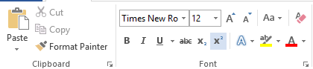

Figure ‎6.1: inserting power to the unit using superscribing tools using Microsoft Word

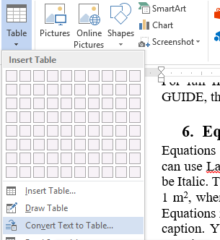

Figure ‎6.2 convert text to table

## Plagiarism

Whenever you make use of other people's facts or ideas, you must indicate this in your text, if you are writing an identical text you must include it in quotations, but if you summarize or paraphrase the text you must include its reference and use citations. Many websites and applications are applicable to detect plagiarism nowadays. Unreferenced text is assumed as your work, idea, or common knowledge, if it is not, then it is assumed to be plagiarized.

## References

|  |  |
| --- | --- |
| [1] | T. S. Rappaport, Wireless Communications: Principles and Practice, 2nd ed., Prentice Hall PTR, 2002. |
| [2] | M. Afshang and H. S. Dhillon, "Fundamentals of modeling finite wireless networks using binomial point process," *IEEE Trans. Wirel. Commun.,* vol. 16, p. 3355–3370, 2017. |

## Acknowledgment

Thanks to all who support me in doing this work.

## Appendix A: Table of Contents

The table of contents is a pivotal part of technical reports, readers will test the topic included in the report, and they may have knowledge about some sections and they want to escape them and shift immediately to the interested section. Using the Table of Contents, they can easily move to the page number they want to read. The following steps are used for inserting the Table of Contents.

1. Select references menu
2. Click on Table of Contents
3. Select Automatic Table 2 as shown in Figure ‎10.1
4. If the popup information box is shown as in Figure ‎10.2
5. Click on Add Text and select the level of your headers format as shown in Figure ‎10.3
6. You can update the table of contents while you writing a new section or if you change the header text as shown in Figure ‎10.4
7. Your final table of contents must be similar to the Table of Contents shown in Figure ‎10.5

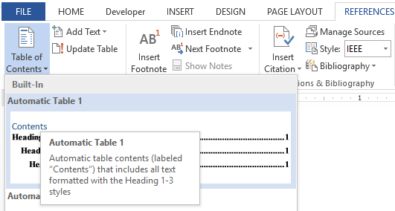

Figure ‎10.1 Selecting table of contents format

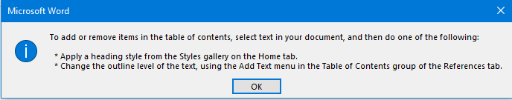

Figure ‎10.2 Information pop-up window

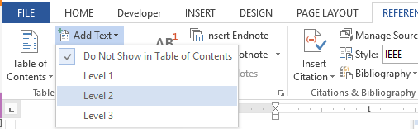

Figure ‎10.3 Select which text is included in the table of contents



Figure ‎10.4 updating the contents of the table of contents

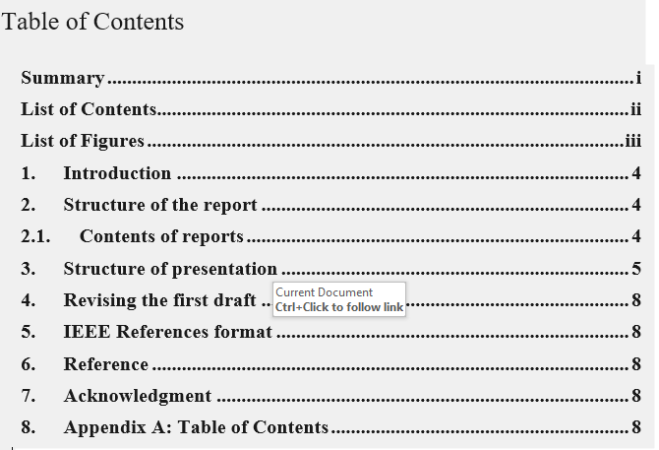

Figure ‎10.5 Table of contents example